Marathwada Shikshan Prasarak Mandal’s

**Deogiri Institute of Engineering and Management Studies,**

**Chatrapati Sambhajinagar**

**Project Report**

**on**

**Golden Gamers**

Submitted By

**Harsh Thakur (CS4134)**

**Jayesh Inamdar (CS4137)**

**Dr. Babasaheb Ambedkar Technological University**

**Lonere (M.S.)**



Department of Computer Science and Engineering **(TNR-16)**

**Deogiri Institute of Engineering and Management Studies,**

**Chatrapati Sambhajinagar**

(2023- 2024)

**Project Report**

**on**

**Golden Gamers**

Submitted By

**Harsh Thakur (CS4134)**

**Jayesh Inamdar (CS4137)**

**In partial fulfillment of**

**Bachelor of Technology**

**(Computer Science & Engineering)**

Guided By

**Mr. Pankaj Durole**

Department of Computer Science & Engineering

**Deogiri Institute of Engineering and Management Studies,**

**Chatrapati Sambhajinagar**

(2023- 2024)

**CERTIFICATE**

This is to certify that, the Project entitled “**Golden Gamers**” submitted by

**Harsh Thakur, Jayesh Inamdar** is a bonafide work completed under my supervision and guidance in partial fulfillment for award of Bachelor of Technology (Computer Science and Engineering) Degree of Dr. Babasaheb Ambedkar Technological University, Lonere.

Date: Place: Chatrapati Sambhajinagar

**Mr. Pankaj Durole Mr. S. B. Kalyankar**

Project GuideHead of Department

**Dr. S. V. Lahane Dr. U. D. Shiurkar**

Dean Academics Director

**DECLARATION**

This is to certify that, the partial project report entitled, “**Golden Gamers**” Submitted by Harsh Thakur, Jayesh Inamdaris a bonafide work completed under my supervision and guidance in partial fulfillment for award of bachelor’s degree in computer science and engineering of Deogiri Institute of Engineering and Management Studies, Chatrapati Sambhajinagar under Dr. Babasaheb Ambedkar Technological University, Lonere.

Place: Chatrapati Sambhajinagar

Date:

Mr (Pankaj Durole)

External Examiner Guide

**Abstract**

In an era dominated by technological advancements, it is imperative that we ensure that everyone, including the elderly, can benefit from the positive aspects of these innovations. "Golden Gamer" is a pioneering gaming application designed specifically for elderly individuals, aiming to foster their hand-eye coordination, cognitive abilities, and overall mental well-being. This app is a testament to our commitment to inclusivity and addressing the unique needs of every age group in the digital landscape.

As the global population ages, there is a growing need for technologies that cater to the specific cognitive and physical challenges faced by the elderly. Maintaining and enhancing cognitive abilities, along with mental well-being, are critical aspects of healthy aging. Through engaging gameplay, "Golden Gamer" seeks to address these issues, ultimately contributing to an improved quality of life for seniors.

The primary purpose of Golden Gamer is to provide a user-friendly platform for elderly individuals to engage in activities that stimulate their cognitive functions and hand-eye coordination. By offering a range of carefully curated games, each designed with the specific needs and preferences of this demographic in mind, the app aims to create an environment that promotes mental agility, social interaction, and a sense of accomplishment.

Memory games within the app challenge users to recall patterns, sequences, and information, contributing to the enhancement of their memory retention and recall abilities. The app features puzzles and challenges that stimulate analytical thinking, encouraging users to develop strategies and exercise their problem-solving skills. Through interactive games that require precise coordination between visual perception and manual dexterity, Golden Gamer aids in maintaining and improving hand-eye coordination, crucial for daily tasks and activities.

Golden Gamer stands as a testament to the potential of technology to enhance the lives of elderly individuals. By offering a tailored gaming experience that targets cognitive functions and hand-eye coordination, this app contributes to the holistic well-being of its users. Through ongoing research, user feedback, and updates, Golden Gamer will continue to evolve, ensuring that it remains at the forefront of digital solutions for the elderly.

**Contents**

**List of Figures**

**1. INTRODUCTION**

1.1 Introduction

1.2 Necessity

1.3 Objectives

1.4 Theme of the project

**2. LITERATURE SURVEY**

2.1 Introduction

2.2 Cognitive Aging and Technology

2.3 Hand-Eye Coordination in Aging Individuals

2.4 Benefits of Gaming for the Elderly

2.5 Social Interaction and Aging

2.6 Accessibility and User-Friendly Design

2.7 Apps which we have referred

2.8 Some Research Papers

**3. SYSTEM DEVELOPMENT**

3.1 Requirement Specification

3.1.1 DFD (Level-0, Level-1, Level-2)

3.1.2 UML Diagrams

3.2 User Interface Design

3.3 E-R Diagram

**List of Figures**

**Figure Illustration Page No.**

* 1. Level-0 DFD
  2. Level-1 DFD
  3. Level-2 DFD
  4. Activity Diagram
  5. Component Diagram
  6. Object Diagram
  7. Main Menu
  8. Games Menu
  9. N-Puzzle Game
  10. Bubble Shot Game
  11. Settings Menu
  12. Sudoku Game
  13. Memory Match Layout
  14. Memory Match Game
  15. Hangman Game
  16. Tic-Tac Toe Game
  17. ER Diagram

**1.INTRODUCTION**

**1.1 Introduction:**

In today's fast-paced, technology-driven world, the potential for digital innovation to improve lives knows no bounds. It is with great pleasure that we introduce you to "Golden Gamer" - a groundbreaking gaming application meticulously designed to cater to the unique needs of our revered elderly population. With a deep understanding of the challenges that can accompany aging, our app seeks to be a beacon of empowerment, providing a platform that not only entertains but also actively contributes to the well-being of this cherished demographic.

Golden Gamer is more than just an app; it's a testament to our commitment to inclusivity and our recognition of the wisdom and experience that older generations bring to the table. Through a thoughtfully curated selection of games, we aim to invigorate hand-eye coordination, stimulate cognitive faculties, and nurture overall mental health. It is a bridge between generations, uniting the timeless values of wisdom with the boundless potential of modern technology.

The genesis of Golden Gamer arose from a deep-seated belief that everyone, regardless of age, should have the opportunity to benefit from the wonders of digital engagement. As the world progresses, so too should our means of ensuring that every individual, young or old, can participate in and reap the rewards of technological advancements. Thus, Golden Gamer serves as a conduit, seamlessly connecting the past with the present, and paving the way for an enriched future.

Join us in this transformative journey, where we celebrate the golden years with a blend of ageless wisdom and cutting-edge technology. Together, let's redefine what it means to age gracefully, as we embark on an adventure that promises not only entertainment but also a genuine enhancement of life's quality. With Golden Gamer, the joys of gaming become an experience that transcends generations, leaving an indelible mark on the hearts and minds of all who partake. Welcome to a new era of digital empowerment, where age is no barrier to the boundless possibilities of fun, learning, and mental well-being.

**1.2 Necessity:**

**I. Addressing Cognitive Aging:**

Cognitive abilities naturally change with age. Your app addresses this by providing stimulating games that target memory, problem-solving, and critical thinking skills. This is essential for maintaining mental agility and preventing cognitive decline.

**II. Improving Hand-Eye Coordination:**

As people age, maintaining hand-eye coordination becomes increasingly important for daily tasks. Golden Gamer offers interactive games that help users enhance this crucial skill, contributing to their overall independence and well-being.

**III. Mental Health and Well-being:**

Older individuals may face challenges related to mental health, including feelings of isolation or depression. Your app fosters a sense of achievement, social interaction, and mental stimulation, promoting a positive mental outlook and overall well-being.

**IV. Inclusivity and Accessibility:**

Many older adults may not be as tech-savvy as younger generations. Golden Gamer ensures inclusivity through a user-friendly interface, customizable features, and accessibility options, making it accessible to a wide range of users.

**V. Social Interaction and Connectivity:**

Loneliness and social isolation are common issues among the elderly. Your app provides a platform for users to connect with friends, family, and fellow gamers, creating a sense of community and reducing feelings of loneliness.

**VI. Evidence-Based Benefits:**

The app's features are grounded in evidence-based research on cognitive stimulation, hand-eye coordination, and mental health. This ensures that users can trust in the effectiveness of the activities they engage in.

**VII. Personalized Experience:**

Recognizing that every individual is unique, Golden Gamer allows users to create personalized profiles and tailor their gaming experience to their preferences and abilities. This personalization ensures a more engaging and effective experience.

**VIII. Continuous Improvement and Progress Tracking:**

The app employs analytics to track user progress, allowing them to see tangible improvements over time. This feedback loop motivates users and provides a clear sense of achievement and progress.

**IX. Safety and Security:**

Providing a secure environment for users is paramount. Golden Gamer ensures data privacy and implements safety measures to create a trusted and secure platform for elderly individuals.

**X. Empowering a Generation:**

Golden Gamer is not just a gaming app; it's a means of empowerment. It recognizes and celebrates the wisdom and experience that the elderly bring to the table, showing that age is no barrier to embracing modern technology and enjoying its benefits.

By addressing these necessities, Golden Gamer serves as a vital tool in enhancing the lives of elderly individuals, offering them a platform for mental and physical engagement, social interaction, and a renewed sense of purpose and accomplishment.

**1.3 Objectives:**

**1. Enhance Cognitive Functionality:**

The primary objective of Golden Gamer is to improve cognitive abilities among elderly users. Through a range of specially designed games, the app aims to stimulate memory, problem-solving, critical thinking, and other cognitive functions.

**2. Promote Hand-Eye Coordination:**

Golden Gamer seeks to enhance hand-eye coordination, a crucial skill that is essential for various daily activities. The app provides interactive games that challenge and improve the user's ability to coordinate visual information with manual dexterity.

**3. Foster Mental Well-being:**

The app aims to contribute to the mental well-being of its users. By providing an engaging and enjoyable platform, Golden Gamer seeks to reduce feelings of isolation and loneliness, while also promoting a positive outlook on life.

**4. Facilitate Social Interaction:**

Golden Gamer endeavors to create a sense of community among its users. Through features like social integration and multiplayer games, the app encourages interaction with friends, family, and fellow gamers, ultimately reducing social isolation.

**5. Ensure Accessibility and Inclusivity:**

One of the key objectives of Golden Gamer is to be accessible to users of all abilities and technological proficiencies. The app strives to provide a user-friendly interface with customizable features, ensuring inclusivity for a diverse user base.

**6. Track and Measure Progress:**

Golden Gamer aims to provide users with tangible evidence of their growth and achievements. The app incorporates analytics to monitor progress, allowing users to see improvements in their cognitive abilities and hand-eye coordination over time.

**7. Personalize User Experience:**

Golden Gamer recognizes that every individual is unique. The app allows users to create personalized profiles, set preferences, and adjust difficulty levels, ensuring a tailored experience that caters to individual abilities and aspirations.

**8. Promote a Sense of Accomplishment:**

Golden Gamer seeks to instill a sense of accomplishment and purpose in its users. By setting achievable milestones and providing a platform for overcoming challenges, the app boosts self-esteem and provides a tangible sense of achievement.

**9. Ensure Data Privacy and Security:**

The app prioritizes the safety and security of user data. Golden Gamer implements robust measures to protect user information, ensuring a trusted and secure environment for elderly individuals to engage with the platform.

**10. Celebrate Aging and Wisdom:**

Golden Gamer aspires to celebrate the wisdom and experience that come with age. It aims to break down stereotypes about technology and aging, demonstrating that seniors can actively engage with modern digital tools and enjoy their benefits.

These objectives collectively form the foundation of Golden Gamer, outlining the app's core mission to enhance the lives of elderly individuals through targeted cognitive stimulation, improved hand-eye coordination, and a heightened sense of well-being and accomplishment.

**1.4 Theme of the Project:**

**Theme: Inclusivity and Empowerment for the Golden Generation**

**Description:**

The theme of "Golden Gamer" is rooted in the belief that technology should be accessible and beneficial for everyone, regardless of age. It celebrates the unique strengths and experiences of the elderly, recognizing them as a vital and vibrant part of our community. Here's an exploration of the key elements that make up the theme:

**1. Inclusivity:** The theme centers around inclusivity, ensuring that the app is user-friendly and welcoming for individuals of all technological backgrounds. It embraces diversity in abilities, catering to a wide range of users and providing features that accommodate various needs.

**2. Empowerment:** "Golden Gamer" empowers its users by providing them with a platform that actively engages and challenges them. Through specially curated games and a personalized experience, the app enables elderly individuals to take control of their cognitive health and well-being.

**3. Celebration of Wisdom:** The theme pays tribute to the wealth of wisdom and experience that comes with age. It emphasizes that aging is not a limitation but an opportunity for growth, learning, and continued self-improvement.

**4. Positive Aging:** "Golden Gamer" promotes a positive outlook on aging. It encourages users to embrace the aging process with enthusiasm and optimism, showing that it's never too late to learn, adapt, and enjoy new experiences.

**5. Connection and Community:** The theme emphasizes the importance of social interaction and a sense of community. "Golden Gamer" provides opportunities for users to connect with friends, family, and fellow gamers, reducing feelings of isolation and fostering a supportive network.

**6. Safety and Trust:** The theme places a strong emphasis on user safety and trust. It ensures that the app provides a secure environment for users to engage with the platform, protecting their privacy and sensitive information.

**7. Progress and Achievement:** The theme encourages a sense of accomplishment and purpose. By setting achievable milestones and tracking progress, "Golden Gamer" empowers users to see tangible improvements in their cognitive abilities and hand-eye coordination.

**8. Modern Aging:** "Golden Gamer" challenges stereotypes about aging and technology. It demonstrates that seniors can actively engage with modern digital tools and enjoy their benefits, showcasing that age is no barrier to embracing new experiences.

**9. Holistic Well-being:** The theme underscores the importance of overall well-being, encompassing mental, emotional, and physical health. "Golden Gamer" aims to contribute positively to the mental health and happiness of its users.

In summary, the theme of "Golden Gamer" embodies a vision of inclusive, empowered aging, where the elderly are celebrated for their unique strengths and contributions. It creates a space where they can thrive, learn, and connect, all while embracing the joys of modern technology.

**2. LITERATURE SURVEY**

**2.1 Introduction:**

In an era characterized by rapid technological advancements, the potential for digital solutions to address the unique needs of diverse demographic groups has never been more apparent. Among these groups, the elderly population stands as a segment with distinct requirements, particularly in the realm of cognitive health and mental well-being. This literature survey is dedicated to exploring the intersection of technology and aging, with a specific focus on the development and impact of the "Golden Gamer" app.

**2.1.A. Contextualizing Cognitive Aging:**

The process of aging brings with it a natural evolution of cognitive functions, presenting challenges that are intrinsic to this phase of life. As individuals advance in age, subtle changes in memory, attention, and information processing may occur. These changes, while a natural part of the aging process, have spurred considerable interest in identifying effective interventions that can mitigate cognitive decline and enhance mental acuity in elderly individuals.

Numerous studies have delved into the complexities of cognitive aging, shedding light on both the normative shifts that occur and the potential for targeted interventions to maintain or even improve cognitive functions. Understanding these nuances is essential in the development of digital solutions like the "Golden Gamer" app, as it seeks to harness technology's potential in optimizing cognitive health for older users.

**2.1.B. The Technological Frontier in Aging Care:**

The advent of digital technology has brought forth a wave of innovations aimed at enhancing the quality of life for individuals across the lifespan. For the elderly, technology holds immense promise in mitigating the challenges associated with cognitive aging. From applications targeting memory retention to those addressing hand-eye coordination, a growing body of literature attests to the efficacy of digital interventions in bolstering cognitive functions.

The "Golden Gamer" app is a prime example of this innovative frontier. By harnessing the power of gamification, it offers a tailored approach to cognitive enhancement, making it accessible and engaging for elderly individuals. This literature survey seeks to contextualize the development of "Golden Gamer" within the broader landscape of technological interventions for the elderly, providing a foundation for understanding its potential impact on cognitive health and overall well-being.

**2.1.C. Objectives of the Literature Survey:**

The primary objectives of this literature survey are twofold. Firstly, it aims to synthesize existing research on cognitive aging, technology-based interventions, and their collective impact on the mental well-being of elderly individuals. By consolidating key findings and insights from diverse studies, this survey provides a comprehensive overview of the current state of knowledge in this field.

Secondly, this survey serves as a foundational resource for the development of "Golden Gamer." By grounding the app in empirical evidence and established best practices, it ensures that the digital intervention is not only user-friendly but also aligned with the specific cognitive and psychological needs of its target audience. This dual-purpose framework underpins the subsequent sections of this literature survey, which delve into the various facets of cognitive aging, technological interventions, and the potential benefits of the "Golden Gamer" app.

**2.2 Cognitive Aging and Technology:**

**2.2.A. Understanding Cognitive Aging:**

Cognitive aging is an intricate process characterized by the natural evolution of cognitive functions as individuals progress through the stages of life. This phenomenon encompasses a range of changes in mental processes, including memory, attention, processing speed, and problem-solving abilities. While these alterations are considered normal and expected components of aging, they may present challenges in performing certain tasks or activities that require a high degree of cognitive engagement.

Numerous studies have sought to unravel the intricacies of cognitive aging, aiming to delineate the nuanced shifts in cognitive functions that occur over time. These investigations have provided valuable insights into the variability of cognitive aging trajectories among individuals and have laid the groundwork for targeted interventions that aim to support and enhance cognitive health in older age.

**2.2.B. The Role of Technology in Mitigating Cognitive Decline:**

Advances in technology have revolutionized the landscape of healthcare and aging care, offering a myriad of opportunities to address the cognitive challenges associated with aging. Digital interventions, particularly those leveraging interactive and engaging platforms, have shown significant promise in preserving and even enhancing cognitive functions in elderly individuals.

Research studies have demonstrated the potential of technology-based interventions in areas such as memory enhancement, attention training, and problem-solving exercises. These interventions often utilize gamification techniques, transforming cognitive training into enjoyable and stimulating activities. The "Golden Gamer" app is a prime example of this paradigm, capitalizing on the interactive nature of gaming to provide a platform that is both entertaining and cognitively enriching for older users.

**2.2.C. Bridging the Gap: "Golden Gamer" as a Technological Solution:**

The "Golden Gamer" app emerges as a testament to the synergistic potential of technology and cognitive health in the aging population. By incorporating evidence-based cognitive training games, the app is uniquely poised to address specific cognitive domains that may experience age-related changes. These games are strategically designed to engage memory recall, critical thinking, and problem-solving skills, offering a holistic approach to cognitive well-being.

Moreover, the interactive nature of the app provides a dynamic platform for continuous engagement. Users are encouraged to participate in regular sessions, ensuring a consistent and stimulating experience. The incorporation of features like progress tracking and customizable difficulty levels further tailors the experience to individual preferences and abilities, maximizing the effectiveness of cognitive training.

The integration of technology into the realm of cognitive aging not only signifies a paradigm shift in aging care but also exemplifies the potential for digital interventions to empower and enrich the lives of older individuals. As we move forward, the "Golden Gamer" app stands at the forefront of this movement, poised to make a meaningful impact on cognitive health and mental well-being in the golden years.

**2.3 Hand-Eye Coordination in Aging Individuals:**

**2.3.A. The Significance of Hand-Eye Coordination:**

Hand-eye coordination, the ability to synchronize visual input with manual dexterity, plays a pivotal role in the execution of everyday tasks. From activities as fundamental as grasping objects to more complex actions like writing or operating electronic devices, precise hand-eye coordination is essential for maintaining independence and efficiency in daily life. As individuals age, preserving and, if possible, enhancing this skill becomes increasingly vital.

**2.3.B. Challenges and Changes in Hand-Eye Coordination with Age:**

Research has demonstrated that hand-eye coordination tends to undergo subtle shifts as individuals progress through the aging process. Factors such as reduced visual acuity, slowed reaction times, and alterations in muscle strength and flexibility can contribute to challenges in maintaining the same level of coordination experienced in earlier years. These changes may lead to difficulties in tasks that demand precise hand movements and visual focus.

Understanding the nuances of hand-eye coordination in aging individuals is imperative in developing interventions that address these challenges. By pinpointing specific areas of decline, interventions like the "Golden Gamer" app can strategically target and engage the relevant cognitive and motor functions, ultimately aiming to bolster this critical skill.

**2.3.C. "Golden Gamer" and Hand-Eye Coordination Enhancement:**

The "Golden Gamer" app recognizes the pivotal role that hand-eye coordination plays in the daily lives of elderly individuals. Through a thoughtfully curated selection of games, the app provides a dynamic platform for users to engage in activities designed to refine their hand-eye coordination. From precision-based tasks to activities that require rapid visual processing, each game is meticulously crafted to challenge and enhance this fundamental skill.

Moreover, the app employs a graduated difficulty system, allowing users to progress at their own pace. This personalized approach ensures that individuals can gradually build their hand-eye coordination abilities in a controlled and supportive environment. The incorporation of progress tracking features also allows users to witness their growth over time, providing tangible evidence of their achievements.

By addressing the specific needs of hand-eye coordination in the aging population, the "Golden Gamer" app seeks to empower users with the tools and experiences necessary to navigate daily tasks with confidence and precision. Through targeted interventions and engaging gameplay, the app serves as a catalyst for maintaining and even elevating this critical skill, ultimately contributing to a higher level of independence and well-being for elderly individuals.

**2.4 Benefits of Gaming for the Elderly:**

**2.4.A. Cognitive Stimulation and Engagement:**

Engaging in interactive and intellectually stimulating activities is crucial for maintaining and even enhancing cognitive functions in older individuals. Gaming provides a dynamic platform for mental engagement, requiring users to process information, make decisions, and strategize. Studies have shown that regular engagement in cognitive activities, such as gaming, can lead to improved memory, enhanced problem-solving abilities, and increased mental agility, all of which are vital components of healthy aging.

**2.4.B. Motor Skills and Hand-Eye Coordination:**

Gaming often involves intricate movements and precise hand-eye coordination, which are essential skills for performing various daily tasks. Through activities that demand quick reflexes and fine motor control, games contribute to the maintenance and improvement of these crucial abilities. This is particularly relevant for elderly individuals, as maintaining strong motor skills can significantly impact their overall independence and quality of life.

**2.4.C. Social Interaction and Community Building:**

One of the remarkable aspects of modern gaming is its capacity to foster social connections, even in a digital environment. Multiplayer games and online communities provide opportunities for elderly individuals to engage in social interactions, reducing feelings of isolation and loneliness. These virtual social networks can lead to meaningful friendships, collaborative experiences, and a sense of belonging, which are vital for mental and emotional well-being.

**2.4.D. Sense of Accomplishment and Purpose:**

Gaming often presents challenges and goals for players to overcome. Achieving milestones and successfully completing tasks within a game instills a sense of accomplishment and purpose. This sense of achievement can significantly boost self-esteem and confidence, providing a tangible measure of progress and success. For the elderly, who may face unique challenges in their daily lives, these accomplishments can be particularly meaningful and motivating.

**2.4.E. Stress Relief and Emotional Well-Being:**

Engaging in enjoyable activities, such as gaming, has been shown to have positive effects on emotional well-being. Playing games can provide a welcomed escape from daily stresses and worries, offering a source of entertainment and relaxation. Additionally, the sense of achievement and camaraderie experienced in gaming can contribute to elevated mood and reduced feelings of anxiety or depression.

**2.4.F. Continuous Learning and Adaptation:**

Gaming often requires learning new rules, strategies, and techniques. This process of continuous learning and adaptation is highly beneficial for cognitive health. It challenges the brain to remain flexible and adaptable, promoting ongoing neural plasticity. For the elderly, engaging in activities that require learning can be particularly advantageous in maintaining mental sharpness and flexibility.

In summary, gaming holds a multitude of benefits for elderly individuals, spanning from cognitive stimulation and social interaction to physical coordination and emotional well-being. As a holistic intervention, gaming has the potential to significantly enhance the overall quality of life for older individuals, providing them with a source of entertainment, social connection, and cognitive enrichment. The "Golden Gamer" app stands as a testament to the immense potential of gaming in the pursuit of healthy and fulfilling aging.

**2.5. Social Interaction and Aging:**

**2.5.A. The Significance of Social Interaction:**

Maintaining strong social connections is a cornerstone of mental and emotional well-being, regardless of age. For elderly individuals, social interaction holds even greater importance as it contributes to a sense of belonging, purpose, and overall life satisfaction. Studies consistently highlight the positive impact of social engagement on various aspects of health, from mental and emotional well-being to physical resilience.

**2.5.B. Challenges of Social Isolation in Aging Populations:**

Despite the recognized benefits of social interaction, many elderly individuals face challenges in maintaining active social lives. Factors such as physical limitations, mobility issues, and the loss of friends or family members can lead to increased social isolation. This isolation, if left unaddressed, can have detrimental effects on mental health, potentially leading to feelings of loneliness, depression, and diminished cognitive function.

**2.5.C. The Role of Technology in Facilitating Social Connection:**

Digital technology, including gaming platforms, has emerged as a powerful tool for mitigating social isolation in older adults. Online communities, multiplayer games, and social networking platforms provide avenues for virtual social interaction, allowing individuals to connect with friends, family, and like-minded peers. This digital connectivity transcends geographic boundaries, offering a sense of camaraderie and support that can be especially valuable for elderly individuals with limited physical mobility.

**2.5.D. "Golden Gamer" as a Catalyst for Social Interaction:**

The "Golden Gamer" app recognizes the paramount importance of social interaction in the lives of elderly individuals. Through features that facilitate multiplayer gameplay and interactive challenges, the app fosters opportunities for users to engage in shared experiences. Whether competing in friendly competitions or collaborating to overcome in-game obstacles, "Golden Gamer" creates a virtual space where users can connect, communicate, and build meaningful relationships.

Moreover, the app's user-friendly interface and accessibility features ensure that individuals of varying technological proficiencies can seamlessly participate in these social interactions. By removing barriers to entry, "Golden Gamer" opens doors for elderly individuals to experience the sense of community and belonging that comes with social engagement.

**2.5.E. Enhancing Emotional Well-Being and Quality of Life:**

Studies have consistently demonstrated that robust social connections are associated with improved emotional well-being and a higher overall quality of life. Engaging in social interactions through platforms like "Golden Gamer" can lead to heightened feelings of happiness, reduced feelings of loneliness, and increased self-esteem. These emotional benefits are integral to the holistic well-being of elderly individuals, contributing to a sense of fulfillment and contentment in their golden years.

In summary, "Golden Gamer" serves as a catalyst for reinvigorating social interactions in the lives of elderly individuals. By leveraging digital technology, the app empowers users to connect with peers, forge new friendships, and experience the joys of camaraderie in a virtual setting. This social engagement, complemented by the cognitive and physical benefits of gaming, positions "Golden Gamer" as a multifaceted tool for enhancing the overall well-being of the elderly population.

**2.6. Accessibility and User-Friendly Design:**

**2.6.A. Catering to Diverse User Profiles:**

Recognizing that the user base of "Golden Gamer" spans a diverse range of individuals, including those who may not be as accustomed to digital interfaces, prioritizing accessibility is paramount. This involves creating an environment where users of varying technological proficiencies and physical abilities can seamlessly navigate and engage with the app.

**2.6.B. User-Friendly Interface Design:**

The user interface (UI) of "Golden Gamer" is thoughtfully crafted with simplicity and intuitiveness in mind. Large, clearly labeled buttons, intuitive navigation pathways, and uncluttered layouts ensure that users can interact with the app without encountering unnecessary complexities. This approach not only facilitates ease of use but also minimizes potential frustration or confusion, enhancing the overall user experience.

2.6.C. Customizability for Individual Preferences:

Recognizing that every user is unique, the app offers a range of customizable features. These include options to adjust font sizes, color schemes, and interface preferences to suit individual needs. By providing such flexibility, "Golden Gamer" empowers users to tailor their experience to their comfort and preferences, ensuring that they can engage with the app in a way that feels most natural and enjoyable to them.

**2.6.D. Voice Commands and Accessibility Features:**

Incorporating voice commands and accessibility features further expands the reach of "Golden Gamer" to users with diverse needs. Voice commands allow individuals with limited dexterity or mobility to interact with the app effortlessly. Additionally, features such as screen readers and text-to-speech functionality ensure that visually impaired users can engage with the app's content effectively, promoting inclusivity for all.

**2.6.E. Responsiveness Across Devices and Platforms:**

"Golden Gamer" is designed to be responsive across a range of devices and platforms. Whether accessed on a smartphone, tablet, or computer, the app adapts seamlessly to different screen sizes and resolutions. This cross-device compatibility ensures that users can engage with the app using the device that is most convenient and comfortable for them.

**2.6.F. User-Centered Design Approach:**

The development of "Golden Gamer" is guided by a user-centered design approach. This involves actively seeking and incorporating user feedback throughout the app's development process. By involving the intended users in the design and testing phases, the app is refined to better meet their specific needs, preferences, and capabilities.

**2.6.G. Accessibility as an Empowerment Tool:**

By prioritizing accessibility and user-friendly design, "Golden Gamer" transcends traditional barriers to entry in the digital realm. It serves as an empowerment tool, enabling users of all backgrounds and abilities to participate in and benefit from the cognitive and social experiences offered by the app. This commitment to inclusivity reinforces the app's mission to enrich the lives of elderly individuals through engaging and accessible technology.

In summary, "Golden Gamer" is characterized by its unwavering dedication to accessibility and user-friendly design. Through intuitive interfaces, customizable features, and a commitment to inclusivity, the app ensures that every user can engage with it comfortably and confidently. This approach not only enhances the overall user experience but also underscores the app's commitment to creating an environment where everyone, regardless of age or ability, can thrive.

**2.7 Apps which we have referred:**

**1) CogniFit:**

This app has minigames that train over 20 cognitive skills, including short-term memory, planning, and hand-eye coordination.

**2) Lumosity:**

This app has a free version that offers challenges that test memory, attention, flexibility, and problem-solving skills.

**3) Mental-UP:**

This app has modules that improve mental and physical abilities, including hand-eye coordination.

**2.8 Some Research Papers:**

**1) Video games as a means to reduce age-related cognitive decline: attitudes, compliance, and effectiveness:**

Walter R. Boot1* Michael Champion2 Daniel P. Blakely1 Timothy Wright1 Dustin J. Souders1 Neil Charness1

1. Department of Psychology, Florida State University, Tallahassee, FL, USA

2. Cognitive Science and Engineering, Technological Entrepreneurship and Innovation Management, Arizona State University, Mesa, AZ, USA

**2) Cognitive benefits of computer games for older adults:**

Elizabeth M. Zelinski, PhD and Ricardo Reyes, BA.

**3) Effect of interactive cognitive-motor training on eye-hand coordination and cognitive function in older adults:**

Pi-Tuan Chan, Wen-Chi Chang, Huei-Ling Chiu, Ching-Chiu Kao, Doresses Liu, Hsin Chu & Kuei-Ru Chou.

**3.SYSTEM DEVELOPMENT**

**3.1 Requirement Specification:**

**3.1.1 DFD:**

Level-0 DFD:

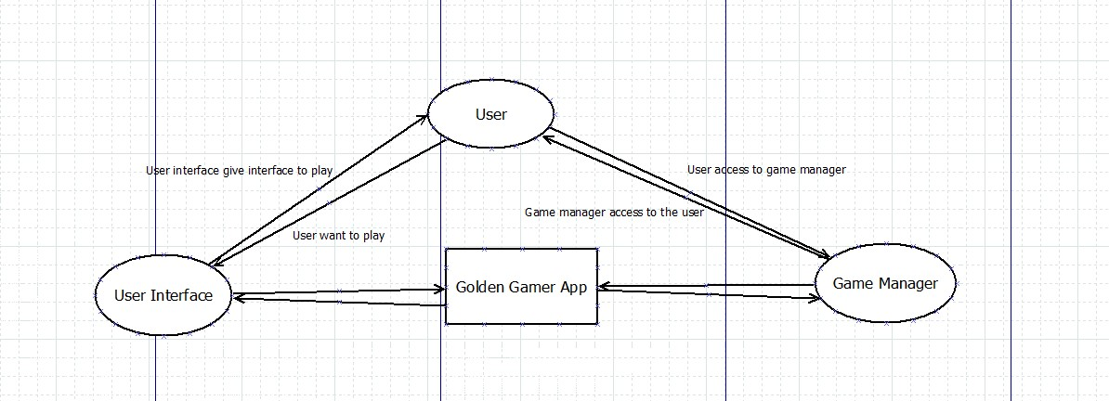

**Figure 3.1.1.1**

Level-1 DFD:

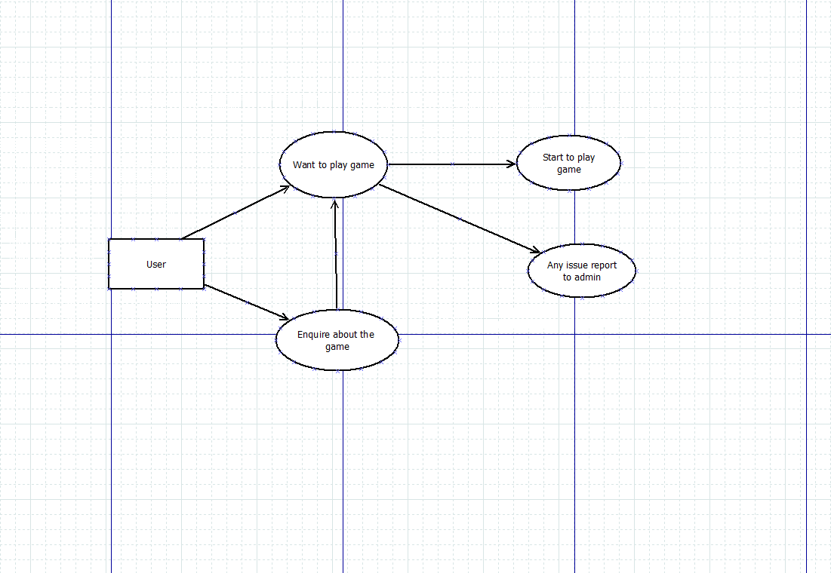

**Figure 3.1.1.2**

Level-2 DFD:

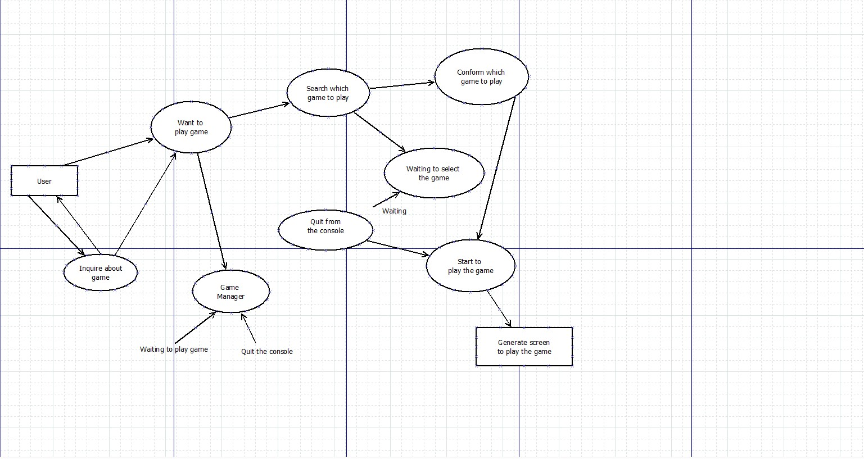

**Figure 3.1.1.3**

**3.1.2 UML Diagrams:**

A] Activity Diagram:

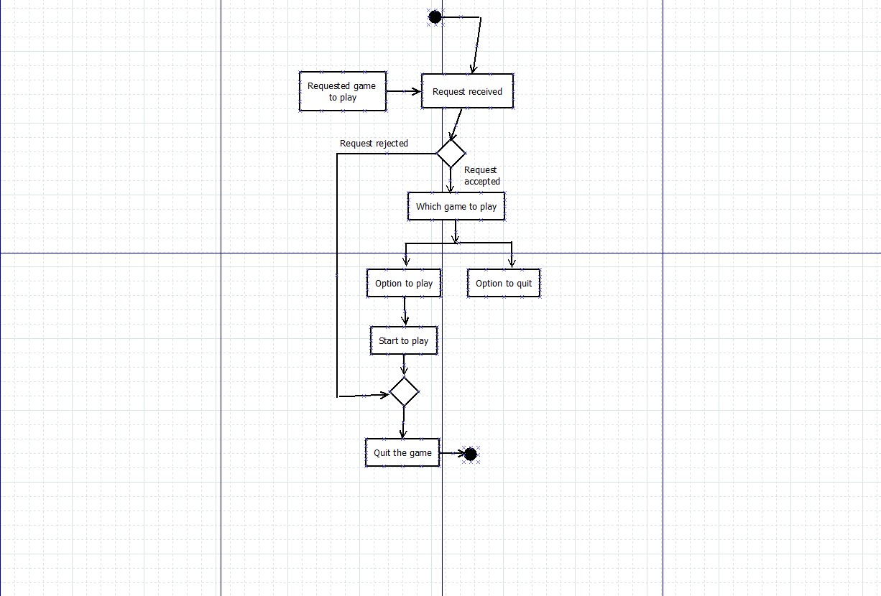

**Figure 3.1.2.1**

B] Component Diagram:

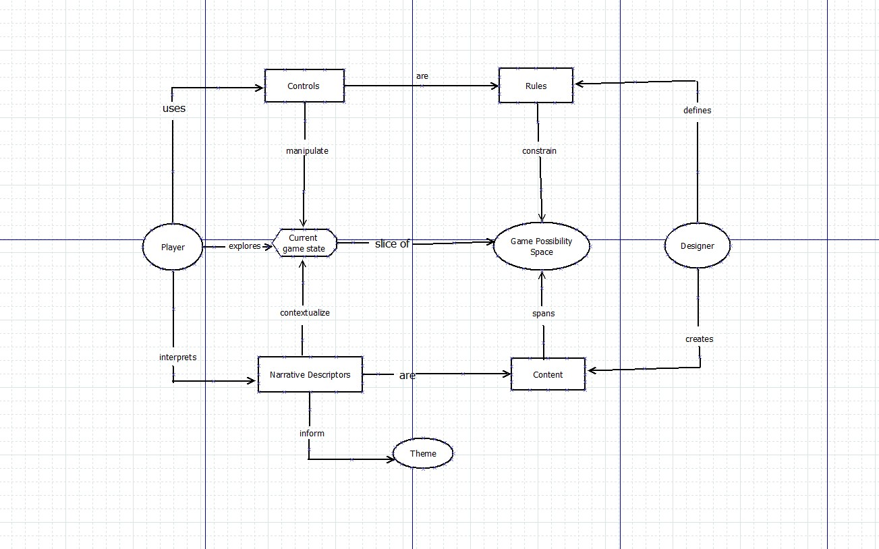

**Figure 3.1.2.2**

C] Object Diagram:

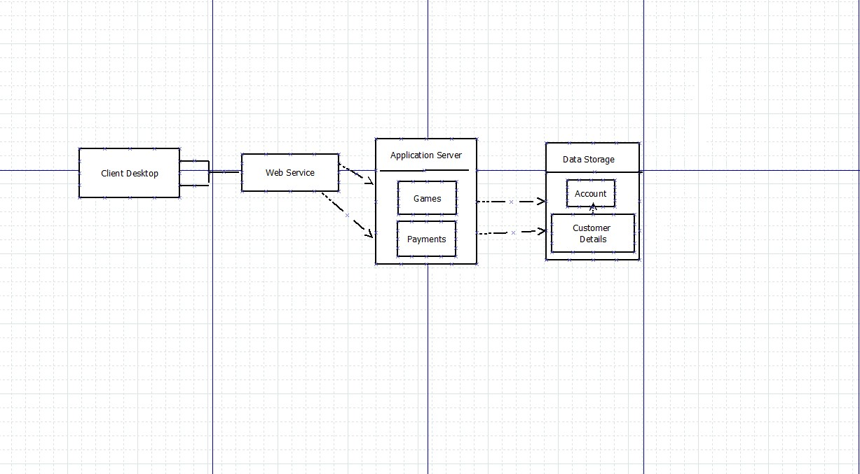

**Figure 3.1.2.3**

**3.2 User Interface Design:**

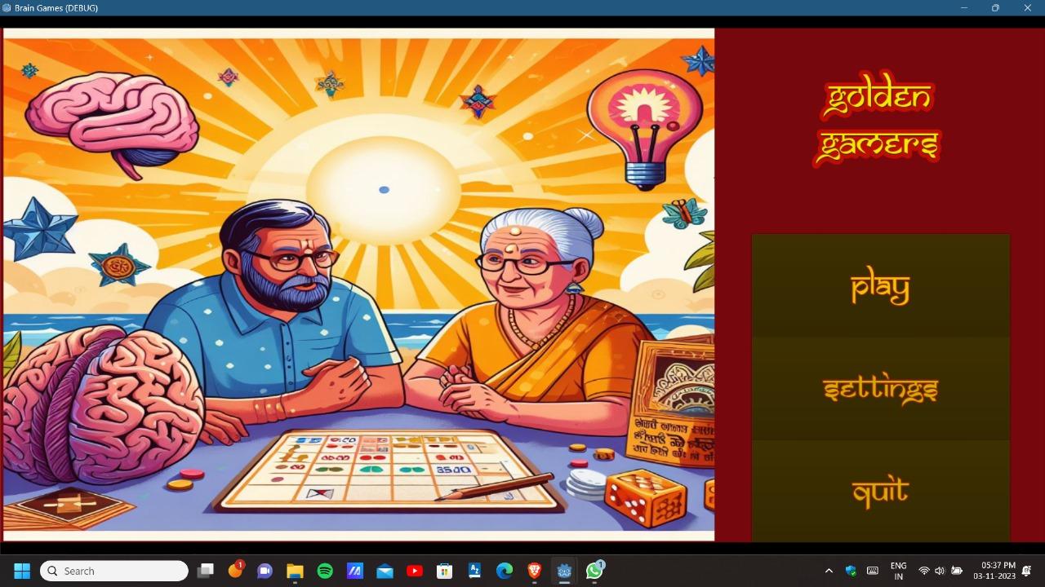

**Figure 3.2.1**

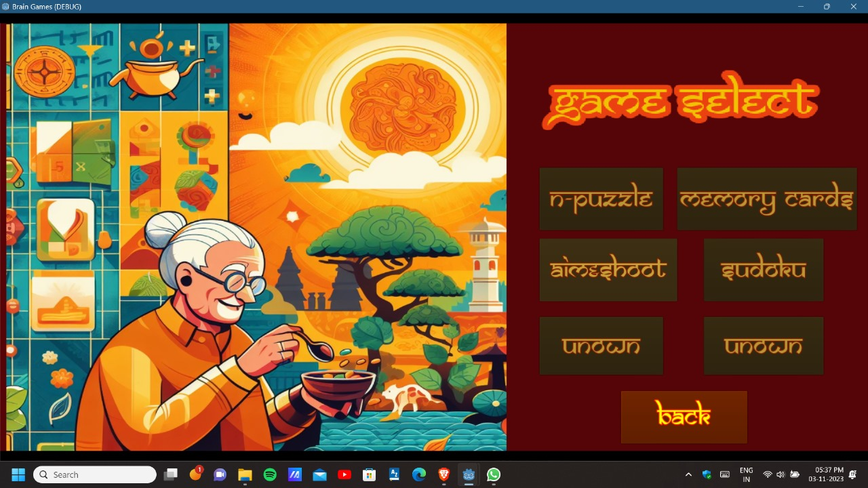

**Figure 3.2.2**

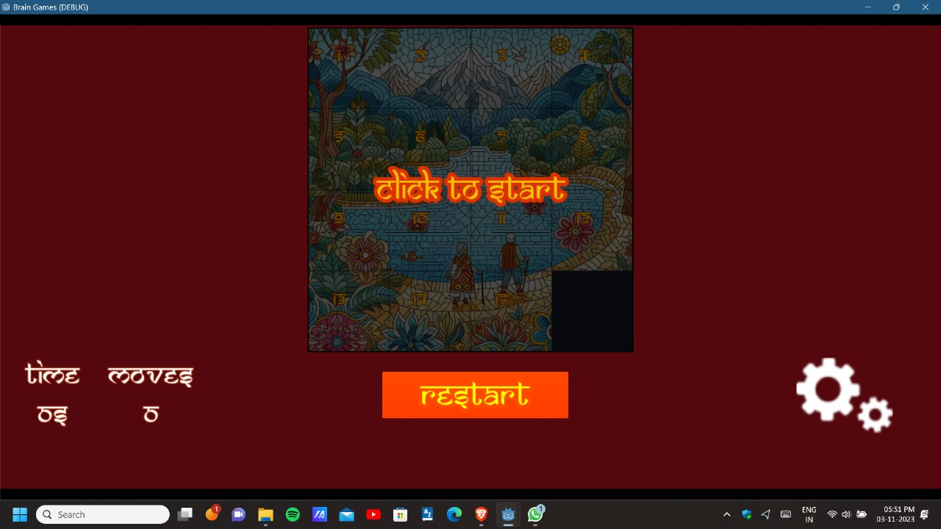

**Figure 3.2.3**

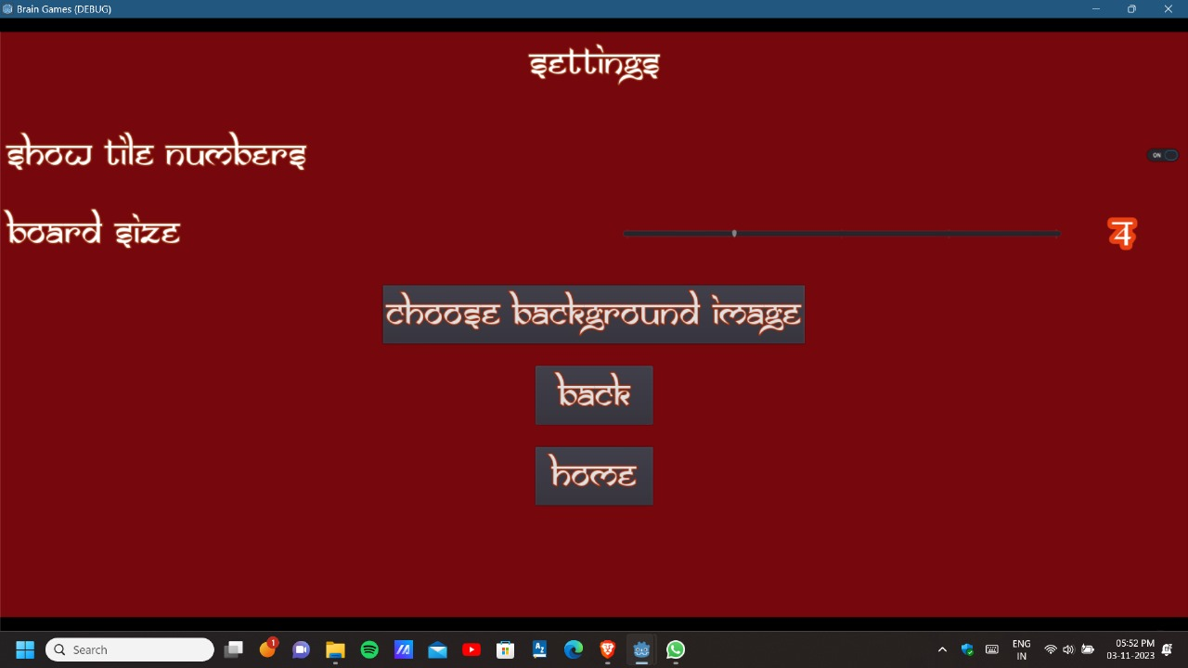

**Figure 3.2.4**

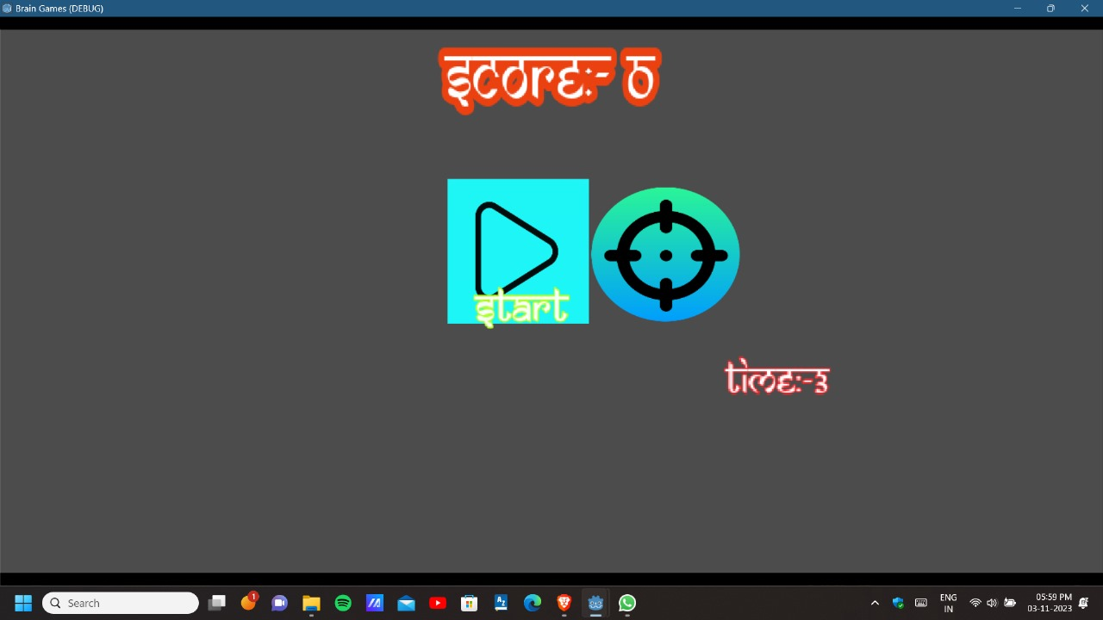

**Figure 3.2.5**

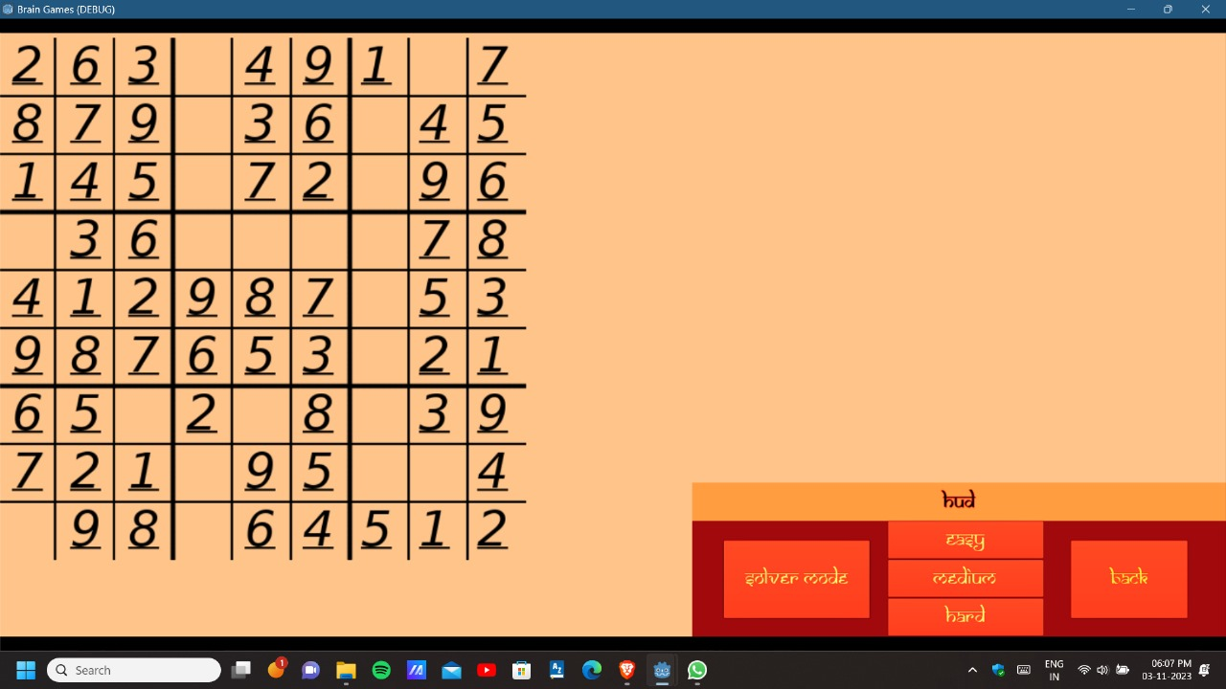

**Figure 3.2.6**

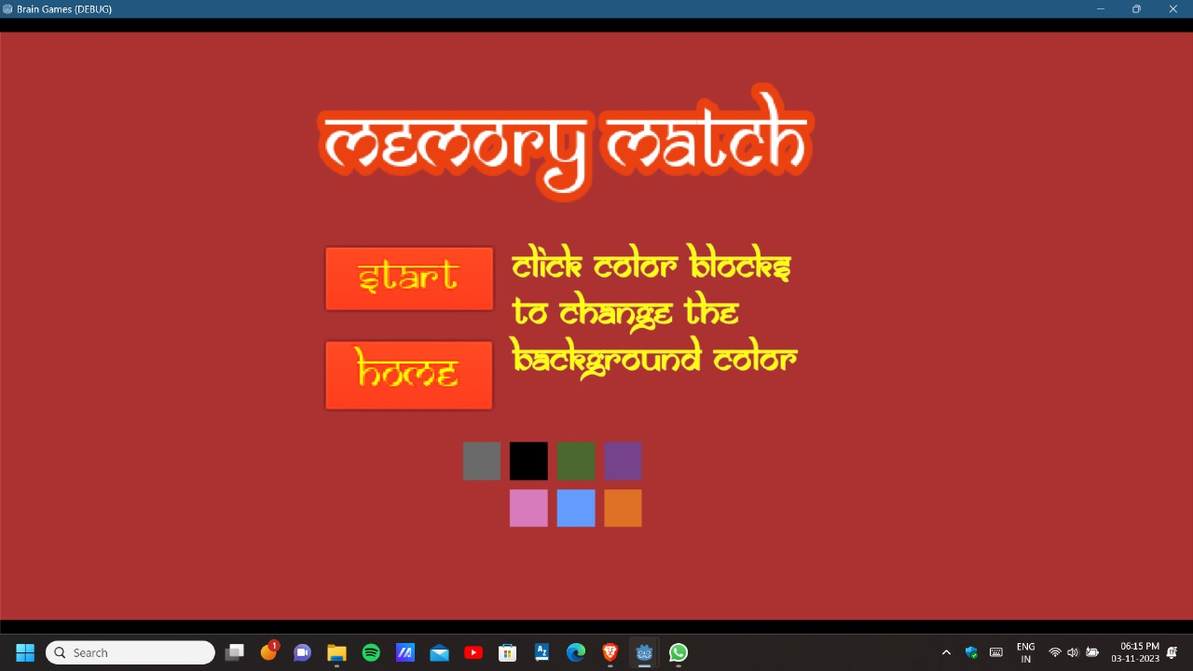

**Figure 3.2.7**

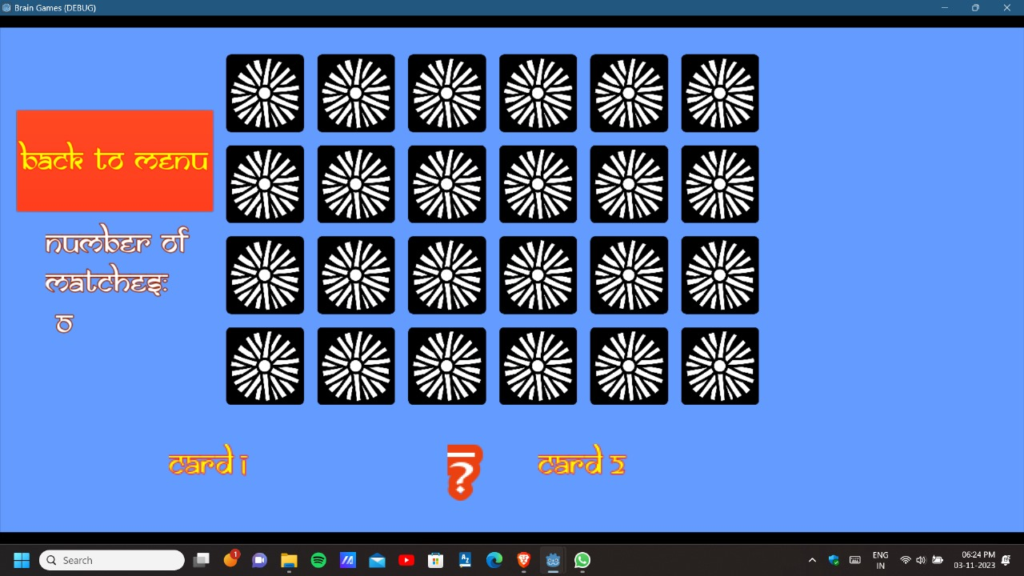

**Figure 3.2.8**

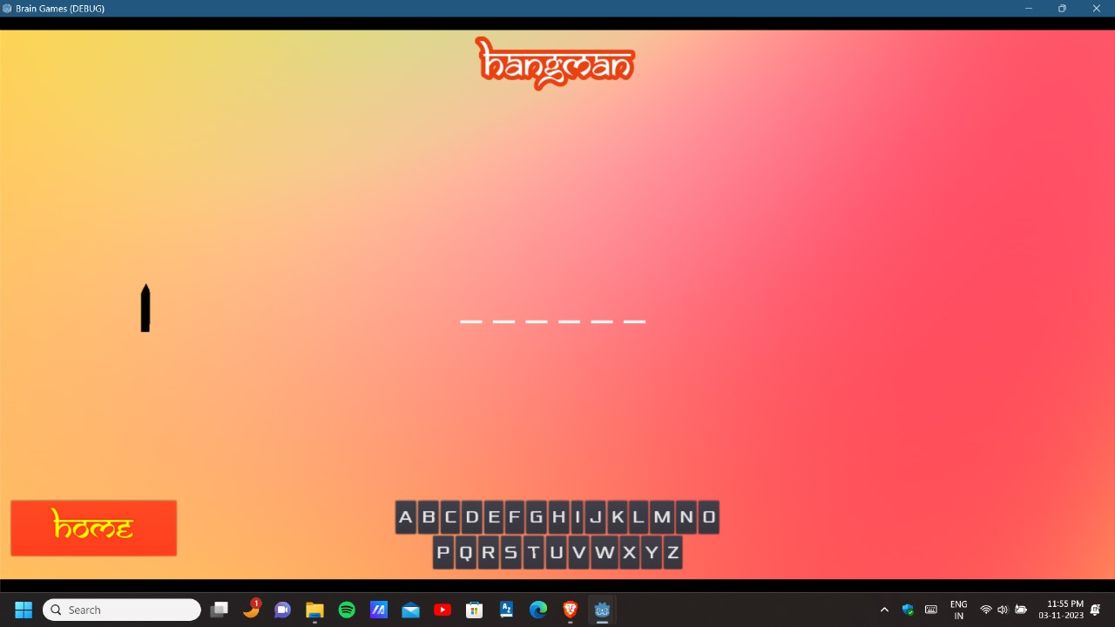

**Figure 3.2.9**

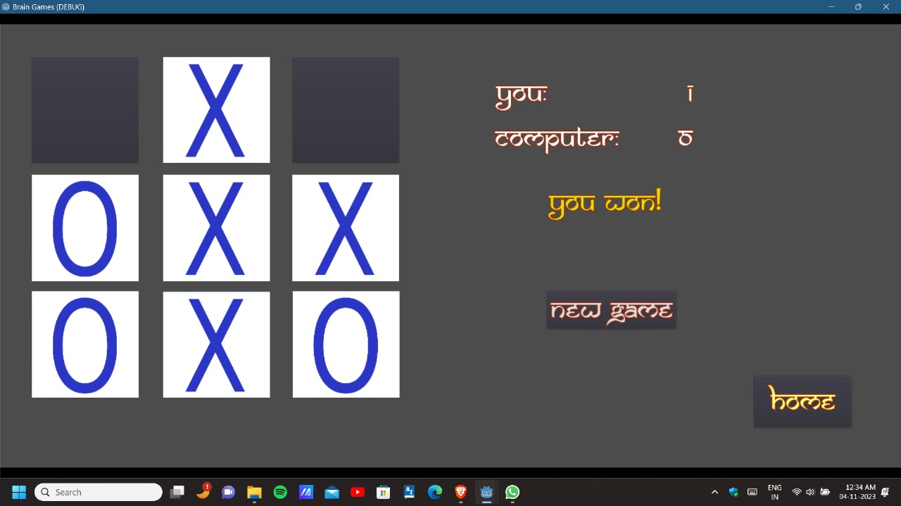

**Figure 3.2.10**

**3.3 Entity-Relationship (ER) Diagram:**

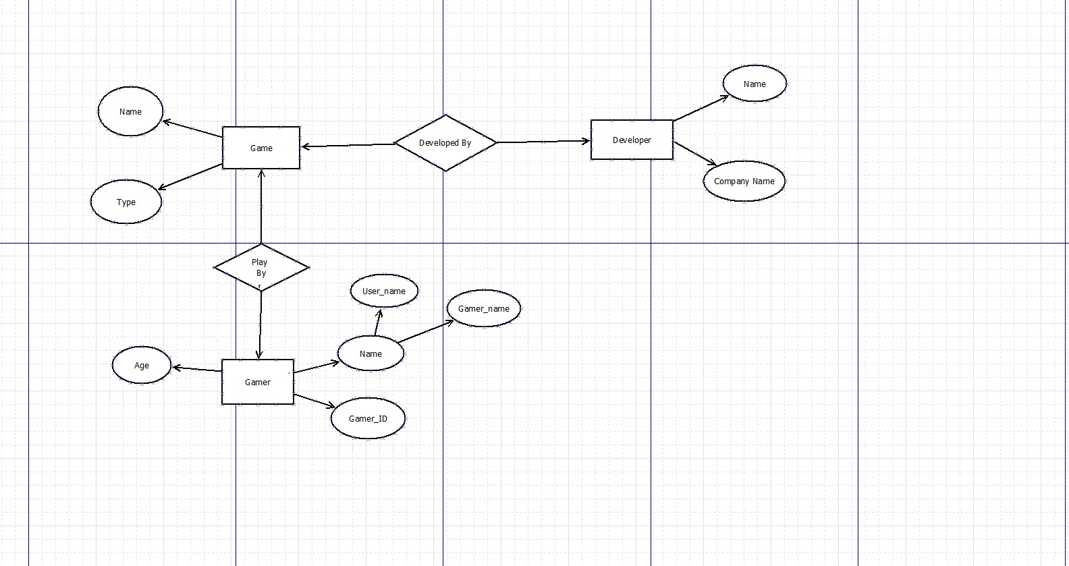

**Figure 3.3.1**